Module 6: Jenkins Assignment – 2

Tasks To Be Performed:
1. Add 2 nodes to Jenkins master
2. Create 2 jobs with the following jobs:
a. Push to test
b. Push to prod
3. Once a push is made to test branch, copy Git files to test server
4. Once a push is made to master branch, copy Git files to prod server

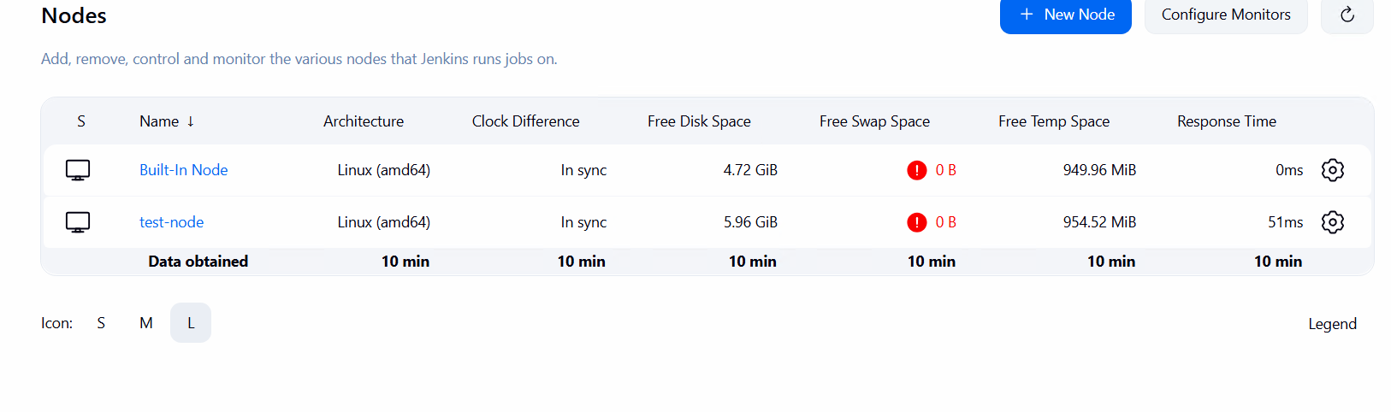
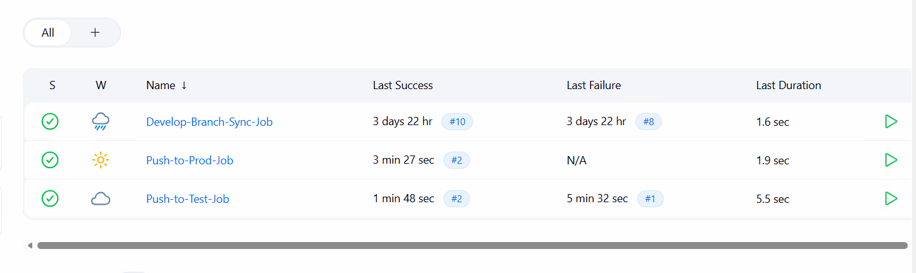
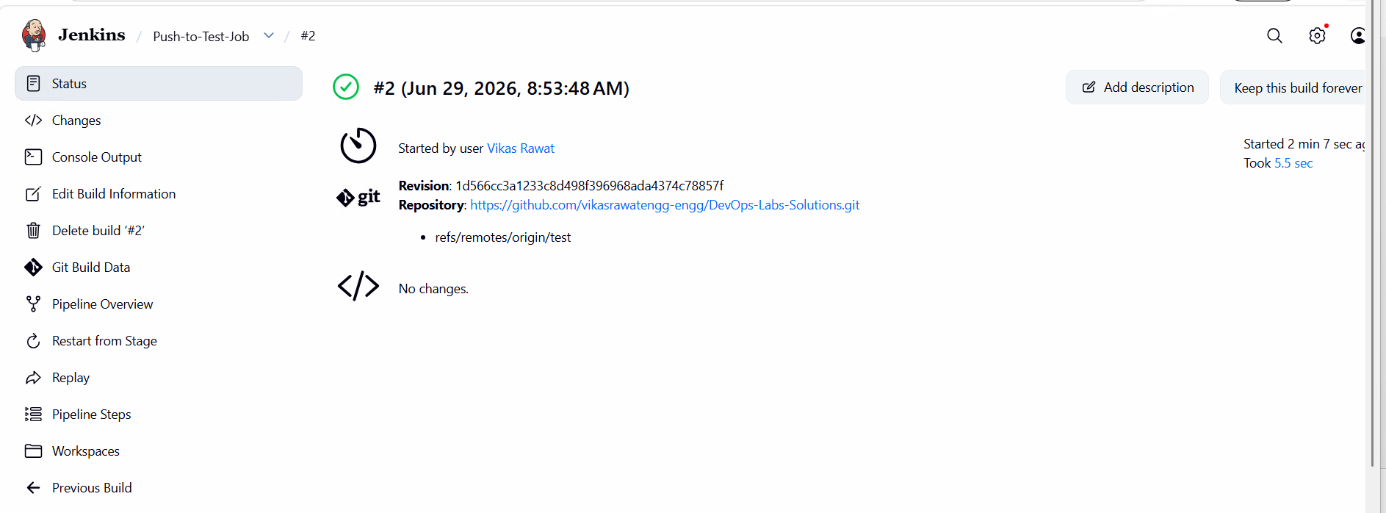

pipeline {
// Restricts this entire build job process to run ONLY on the new attached test instance
agent { label 'test-environment' }

stages {
stage('Clean Target Node Workspace') {
steps {
deleteDir()
echo "Test agent deployment folder safely scrubbed."
}
}

stage('Pull Git Content to Test Server') {
steps {
// Synchronizes your test branch directly into a folder on the test agent host
dir('test-server-deployment') {
git branch: 'test',
credentialsId: 'github-token-id',
url: 'https://github.com/vikasrawatengg-engg/DevOps-Labs-Solutions.git'
}
echo "Success: Synchronized test branch files directly onto the test server runtime host."
}
}
}
}
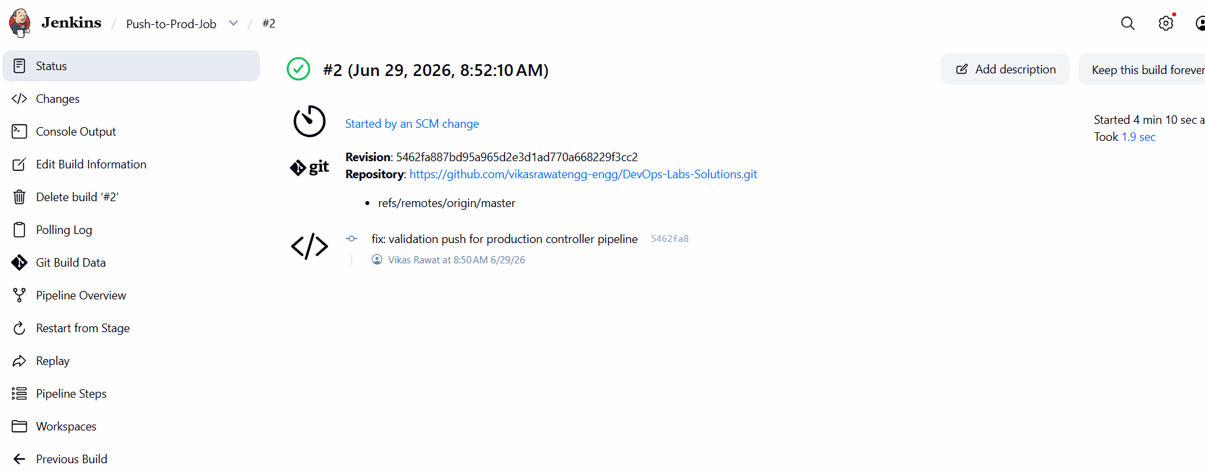
pipeline {
// Instructs the scheduler engine to run this deployment code strictly on the built-in production master
agent { label 'built-in' }

stages {
stage('Clean Production Workspace') {
steps {
deleteDir()
echo "Production core workspace safely cleared."
}
}

stage('Pull Git Content to Prod Server') {
steps {
// Synchronizes your master branch right onto the primary controller local storage layout
dir('prod-server-deployment') {
git branch: 'master',
credentialsId: 'github-token-id',
url: 'https://github.com/vikasrawatengg-engg/DevOps-Labs-Solutions.git'
}
echo "Success: Critical production files deployed onto the prod server safely."
}
}
}
}

